

Summer Vacation Task

By Shreya Sandilya

17BEE1159

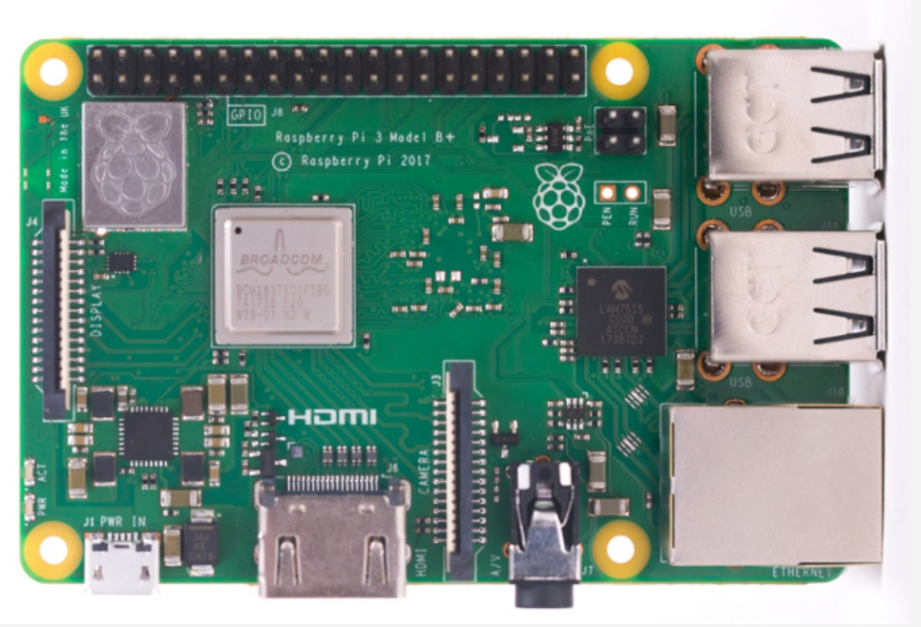RASPBERRY PI:

The raspberry pi is a very cheap computer that runs Linux, but it also provides a set of GPIO(general purpose i/o) pins that allow you to control electronic components for physical computing and explore the Internet of Things(IoT).

The raspberry pi comes in two models, they are model A and model B. The main difference between model A and model B is USB port.

There are many advantages of Raspberry Pi over Arduino, some of them are:

1.This is the main advantage of Raspberry Pi is, it’s capable of doing **multiple tasks** at a time like a computer.  Arduino is good if you just want to blink a LED but if you have hundreds of LEDs needs to be controlled over web page, then Pi is the best suited.

2. Raspberry **Pi is 40 times faster** than Arduino.

3. Raspberry Pi has the **built in Ethernet port**, through which you can directly connect to the networks. While in Arduino, it’s very difficult to connect to network. External hardwares need to be connected and properly addressed using code, to run network using Arduino. E

4. For Arduino you definitively need a electronic background, and need to know about embedded programming languages. But to start with Pi you don’t need to dive into the coding languages and a small knowledge of electronics and its components is enough.

5. One more advantage is that**OS can be easily switched** on the single Raspberry Pi board. Pi uses SD card as flash memory to install the OS, so just by swapping the memory card you can switch the operating system easily.

*Few alternatives to Arduino and Raspberry pi are:*

1. NodeMCU otherwise known as ESP8266:

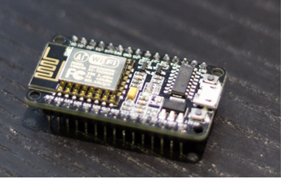

2. Teensy 3:

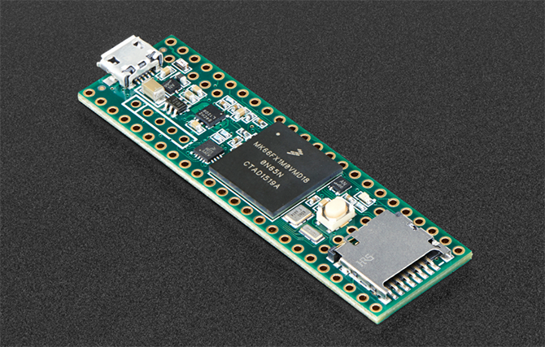

3. MSP430 Launchpad:

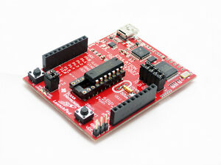

4. STM32, also known as the blue pill:

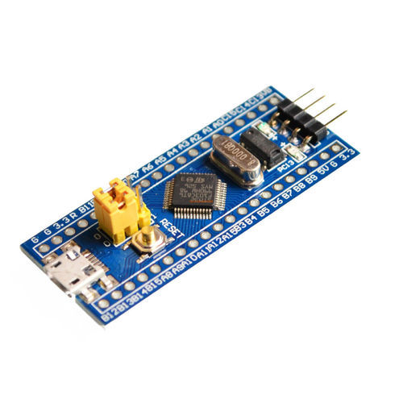Board name: **STM32F103C8T6**

ARM Cortex M based Microcontrollers:

The ARM Cortex-M is a group of [32-bit](https://en.wikipedia.org/wiki/32-bit) [RISC](https://en.wikipedia.org/wiki/Reduced_instruction_set_computer) [ARM](https://en.wikipedia.org/wiki/ARM_architecture) processor cores licensed by [Arm Holdings](https://en.wikipedia.org/wiki/Arm_Holdings). They are intended for [microcontroller](https://en.wikipedia.org/wiki/Microcontroller) use, and have been shipped in tens of billions of devices.

The STM32 family of microcontrollers from STMicroelectronics is based on the ARM Cortex-M 32-bit processor core. STM32 microcontrollers offer a large number of serial and parallel communication peripherals which can be interfaced with all kinds of electronic components including sensors, displays, cameras, motors, etc. All STM32 variants come with internal Flash memory and RAM. It offers a 32 bit product range that combines very high performance, real-time capabilities, digital signal processing, and low power, low voltage operation, while maintaining full integration and ease of development.

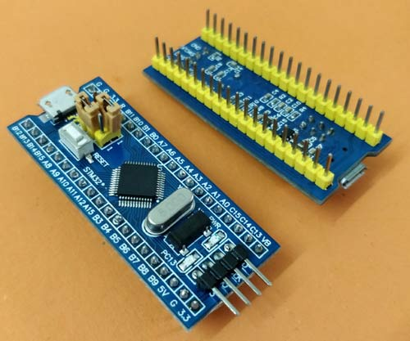 The **STM32F103C8T6**(STM32 board, also called Blue Pill) is a Development board for the ARM Cortex M3 Microcontroller which It looks very much similar to the Arduino Nano. These boards are extremely cheap compared to the official Arduino boards. Also, another important point here is that we can use the same old **Arduino IDE to program our STM32 Boards.**

Microcontrollers name STM32F103C8T6 has a meaning behind it.

* STM » stands for the manufacturers name STMicroelectronics
* 32 » stands for 32-bit ARM architecture
* F103 » stands to indicate that the architecture ARM Cortex M3
* C » 48-pin
* 8 » 64KB Flash memory
* T » package type is LQFP
* 6 » operating temperature -40°C to +85°C

Features of the board:

Architecture: 32-bit ARM Cortex M3

Operating Voltage: 2.7V to 3.6V

CPU Frequency: 72 MHz

Number of GPIO pins: 37

Number of PWM pins: 12

Analog input Pins: 10 (12-bit)

USART Peripherals: 3

I2C Peripherals: 2

SPI Peripherals: 2

Can 2.0 Peripheral: 1

Timers: 3(16-bit), 1 (PWM)

Flash Memory: 64KB

RAM: 20kB

Pin configuration of the board:

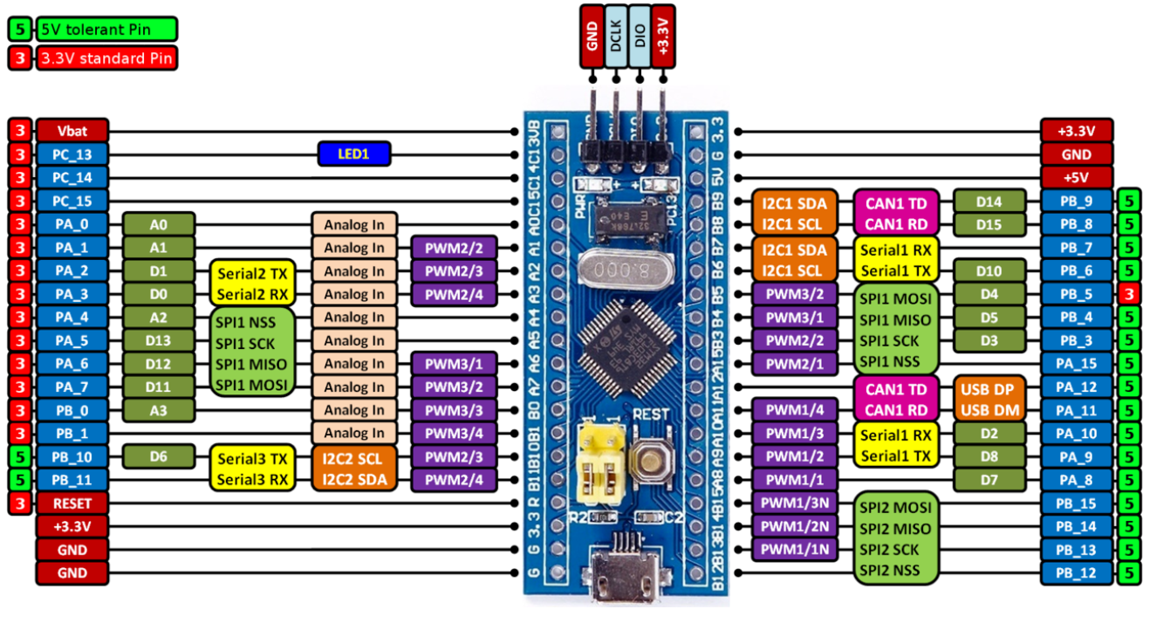

Schematic:

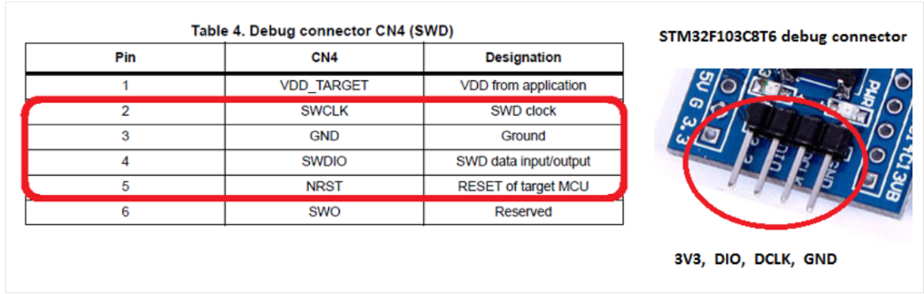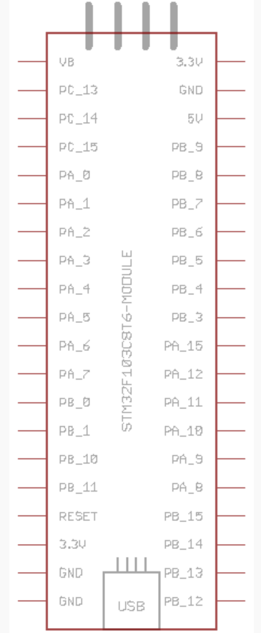

Debug mode pin configuration:

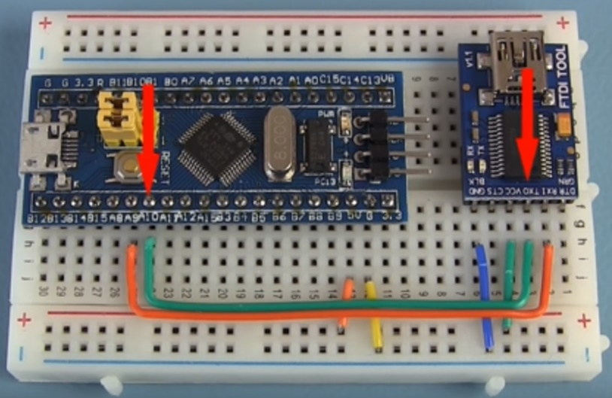Also, when we use STM32F103C8T6 with Arduino IDE, we have to use an FDTI. The FDTI allows us to connect a second device to the hardware serial port on an Arduino Pro, Pro Mini, or other USB-less board without compromising the ability to bootload code from the Arduino IDE. The reason for doing that is, when the STM32 development board is purchased it does not come with an Arduino ready boot loader and hence the board will not be discovered by your computer when connected through the USB.

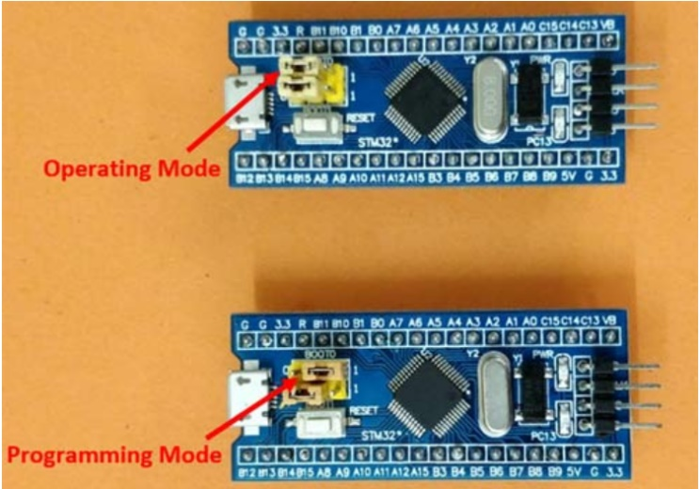Also, before uploading any code on the board we have to first shift the tub jumper to the right and press the reset button, in this manner the board enters program mode.

After uploading the program, the tub jumper can be placed back into the original position and the code can be executed.

SMD Soldering:

SMD stands for Surface Mount Device and indicates that the component is mounted on the surface of the circuit board in contrast to through-hole components which are mounted in holes.

These types of components are getting popular day by day due to its excessive small size, which comes in handy for creating circuits which needs to fit inside one’s pocket.

The smd is mainly done by using two method, done by using the normal soldering wire, and a fine tip soldering rod. Another by using a soldering paste.

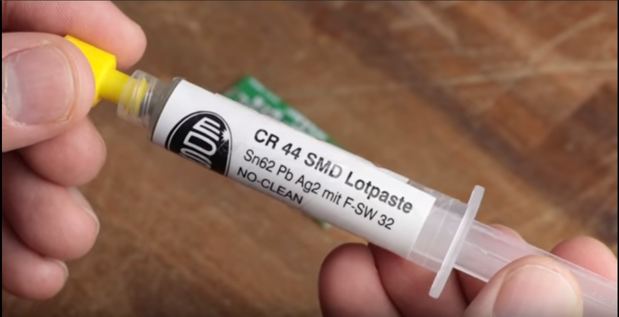

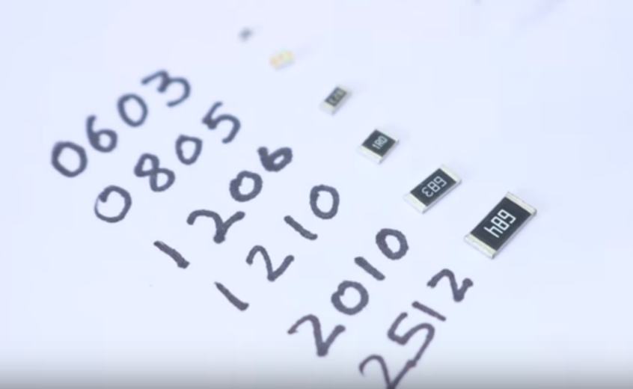While using the normal soldering wire method, for a two terminal component we first solder one terminal place the component on the pcb, then solder the other terminal and then resolder the first terminal, just to insure everything’s in place.

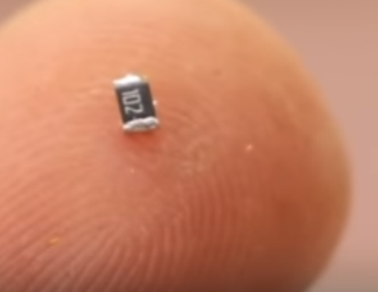

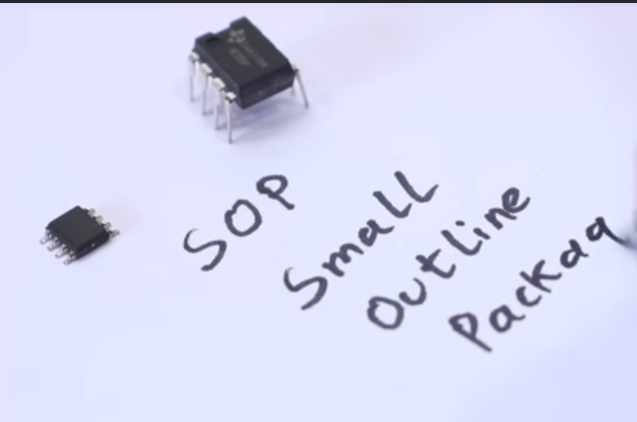

For IC’s again solder the diagonal terminals first and then the rest of the terminals.

Another method is to use the flux stick.

Cover all the ic’s using the flux stick and then using the solder wire sort all the terminals.

Now using some solder wick remove the excess solder.

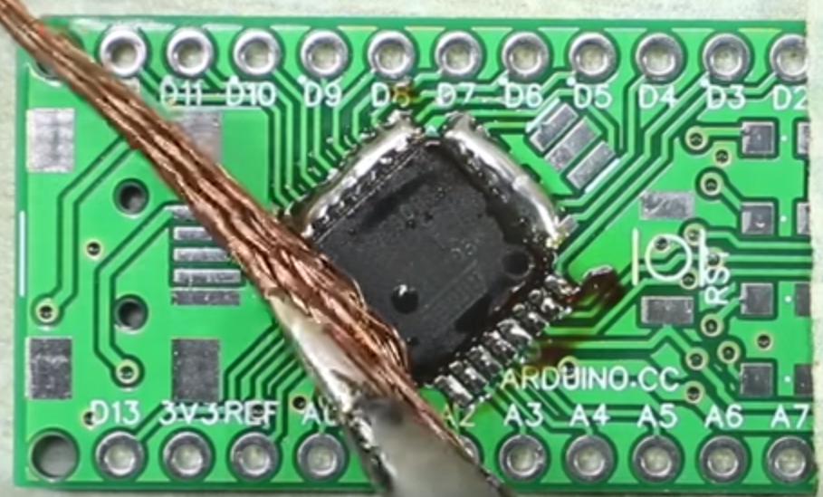

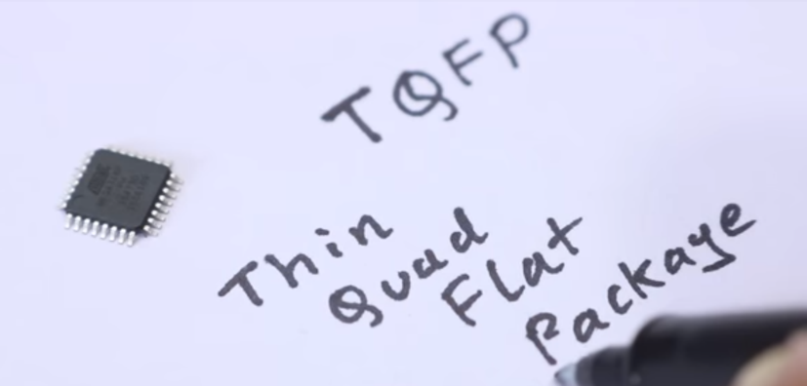

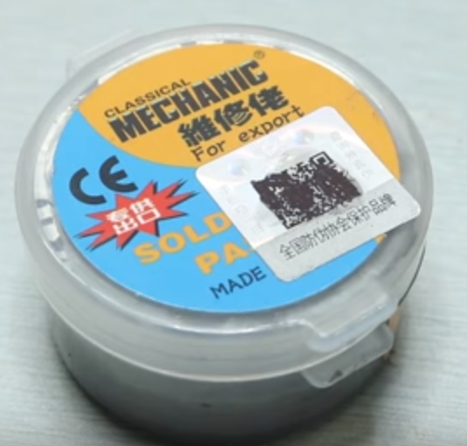Moving on to the other method. Here we use soldering paste and some hot air to solder the components on the pcb.

This is a slightly less messy process and a lot easier.

So, we have to just apply some soldering paste on place where we require to solder the component then place the component there and the blow dry it, till the component is fixed.

The disadvantage with this method is that the component can be excessively heated and the ICs may get burnt.

